Appendix

- XY-Plots Section
Graph 1.1 – XY Plot of Good and Average Numbers for the Six Surveys

Graph 1.2 – XY-Plot of Good and Average Percentage Numbers for the Six Surveys

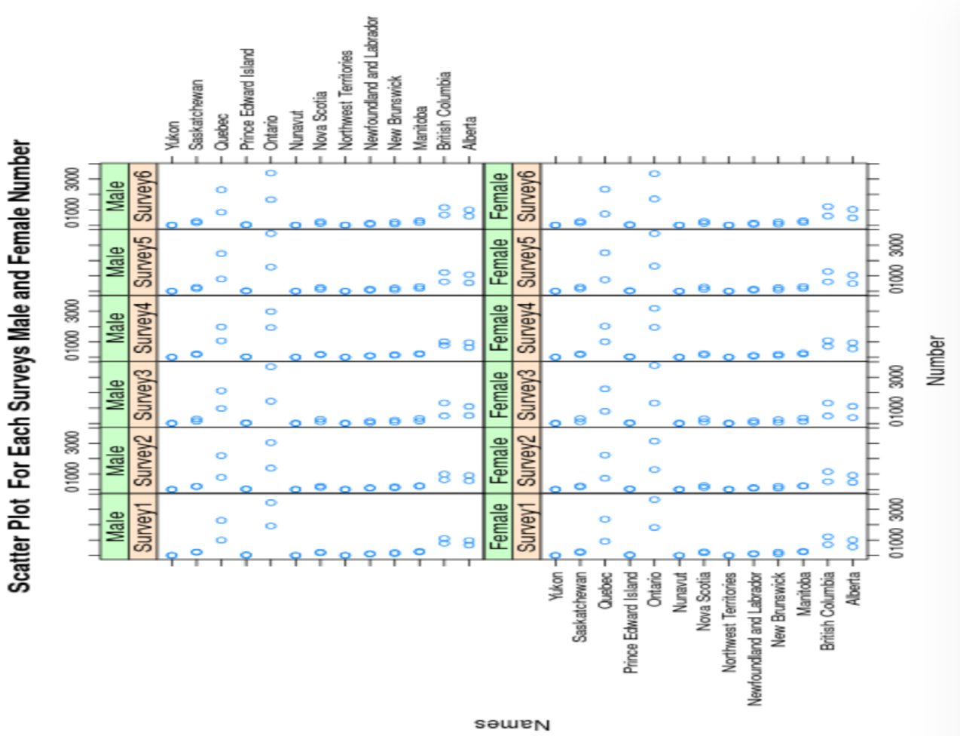
Graph 1.3 - XY-Plot of Male and Female Numbers for the Six Surveys
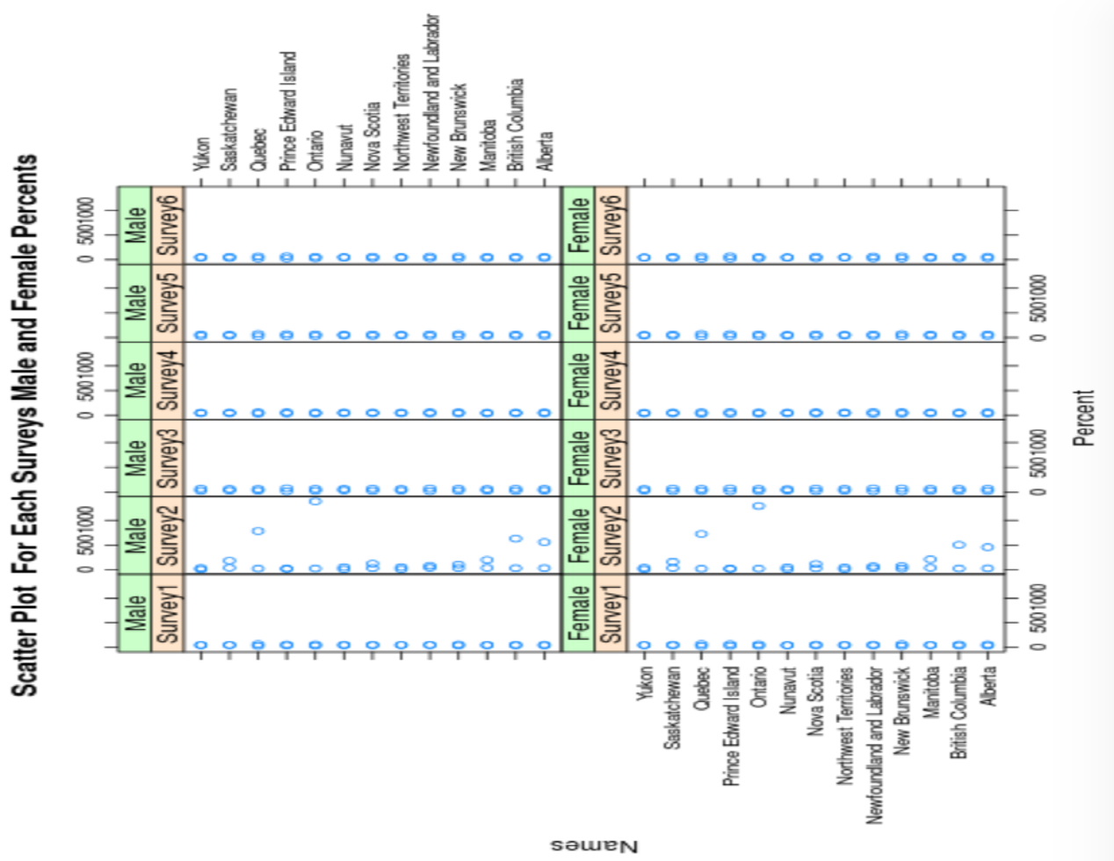
Graph 1.4 - XY-Plot of Male and Female Percentage Numbers for the Six Surveys
- Box and Whisker Section
Graph 2.1 – Box and Whisker Plot 1 – Good Numbers for the Six Surveys
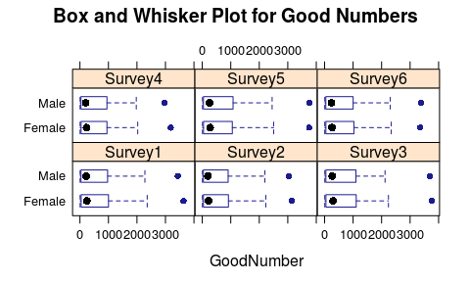

Graph 2.2 – Box and Whisker Plot 2 – Average Numbers for the Six Surveys
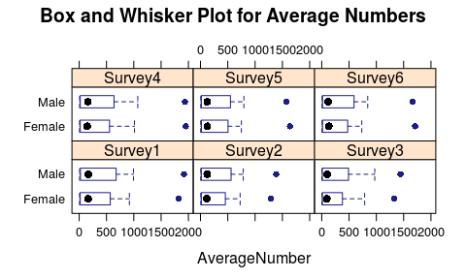

Graph 2.3 – Box and Whisker Plot 3 – The Good Percentage for the Six Surveys
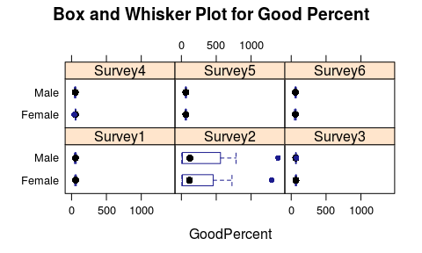
Graph 2.4 – Box and Whisker Plot 4 – Average Percentage for the Six Surveys
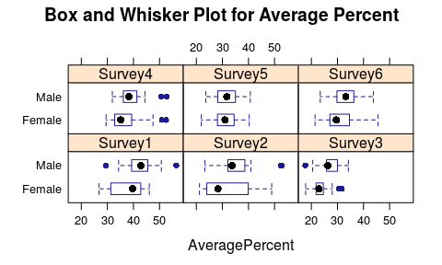

- Histograms Section
Graph 3.1 – Histogram of Survey 1 Good Male and Female Numbers and Average Male and Female Numbers Comparison
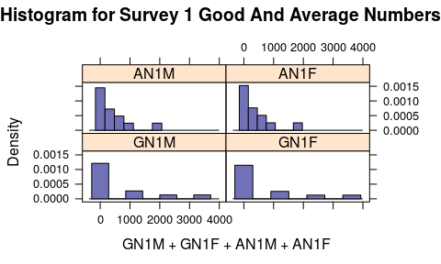
Graph 3.2 – Histogram of Survey 2 Good Male and Female Numbers and Average Male and Female Numbers Comparison
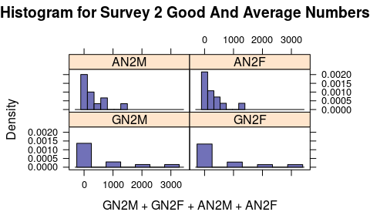

Graph 3.3 – Histogram of Survey 3 Good Male and Female Numbers and Average Male and Female Numbers Comparison
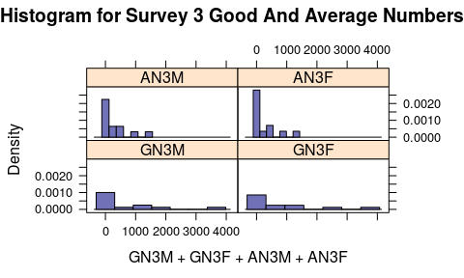

Graph 3.4 – Histogram of Survey 4 Good Male and Female Numbers and Average Male and Female Numbers Comparison
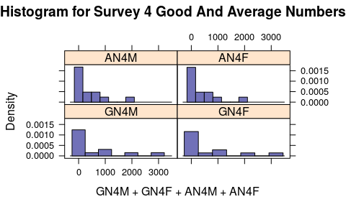
Graph 3.5 – Histogram of Survey 5 Good Male and Female Numbers and Average Male and Female Numbers Comparison
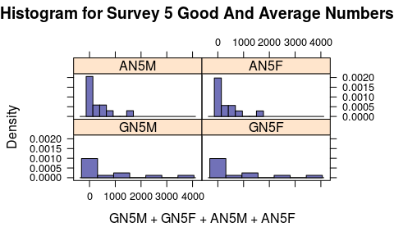

Graph 3.6 – Histogram 6 of Survey 6 Good Male and Female Numbers and Average Male and Female Numbers Comparison
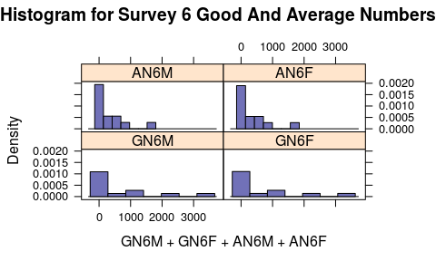

- Bar Graphs Section
Graph 4.1 – Survey 1 Good and Average Numbers

Graph 4.2 – Survey 1 Good and Average Percentages

Graph 4.3 – Survey 2 Good and Average Numbers

Graph 4.4 – Survey 2 Good and Average Percentages

Graph 4.5 – Survey 3 Good and Average Numbers

Graph 4.6 – Survey 3 Good and Average Percentages

Graph 4.7 – Survey 4 Good and Average Numbers

Graph 4.8 – Survey 4 Good and Average Percentages

Graph 4.9 – Survey 5 Good and Average Numbers

Graph 4.10 – Survey 5 Good and Average Percentages

Graph 4.11 – Survey 6 Good and Average Numbers

Graph 4.12 – Survey 6 Good and Average Percentages

